CS 255 System Design Document Template

UML Diagrams

UML Use Case Diagram

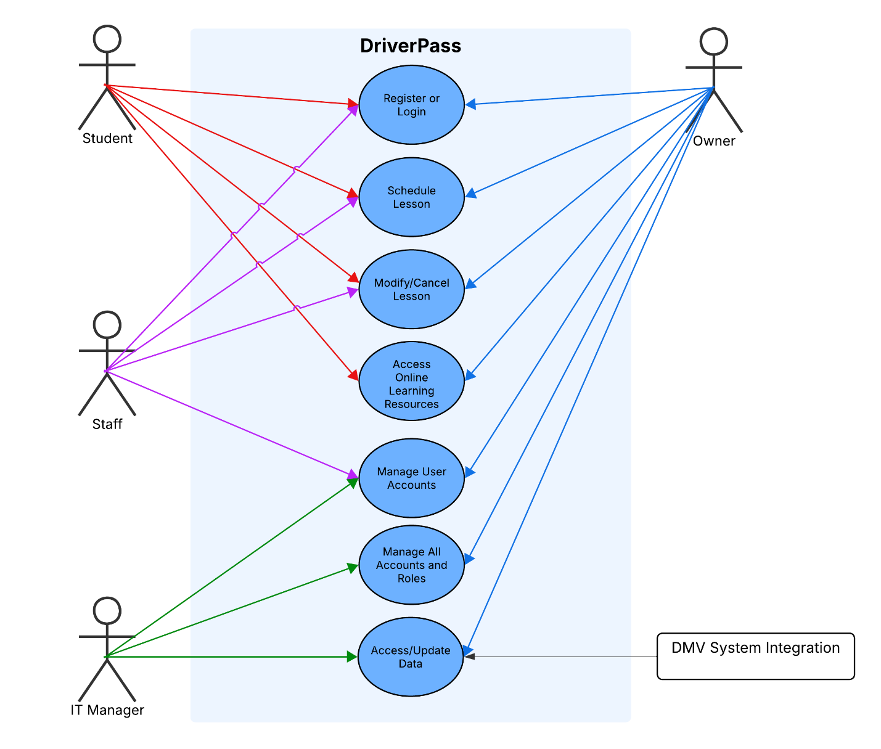

UML Activity Diagrams
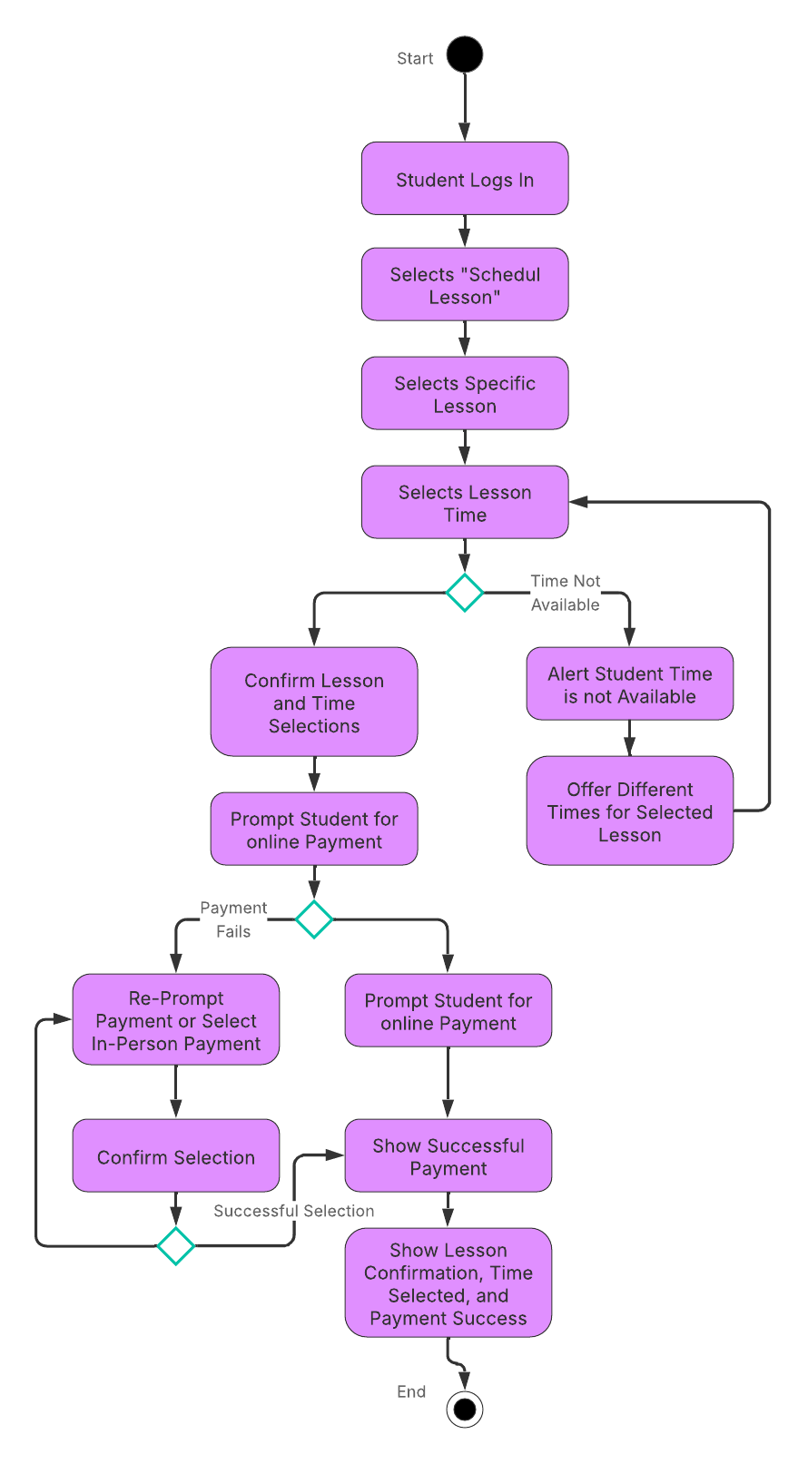
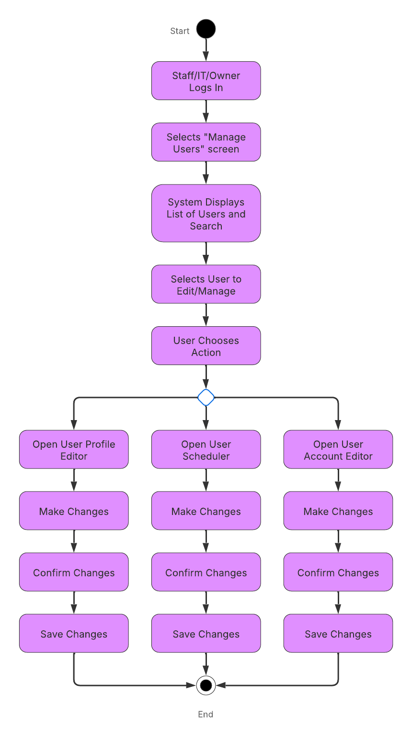

UML Sequence Diagram

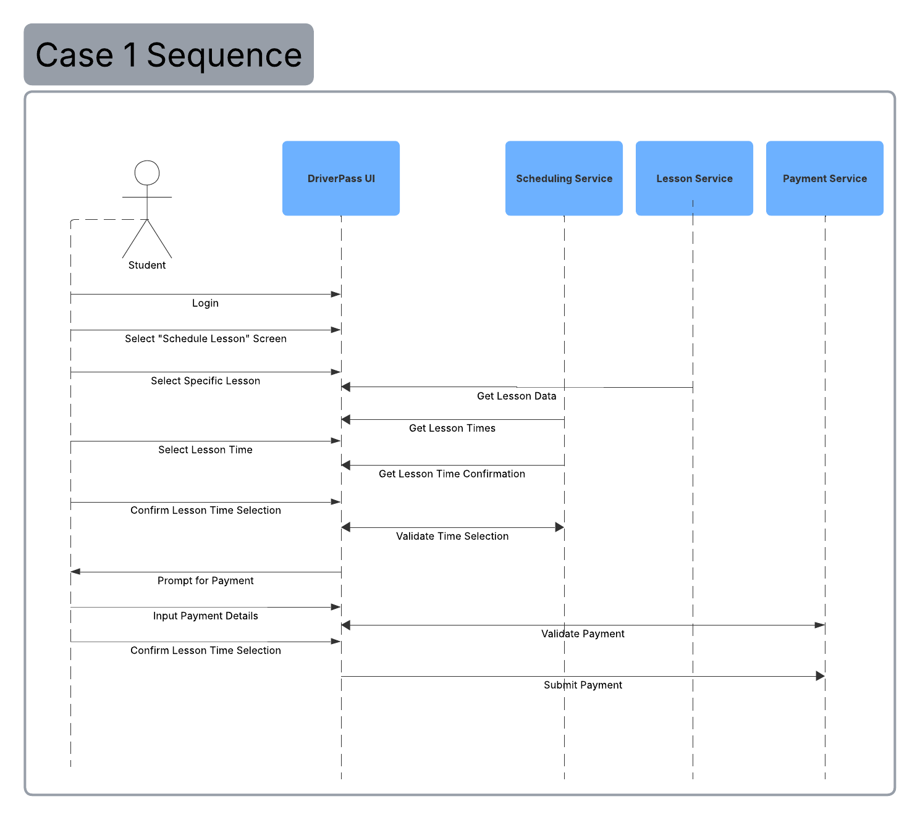

UML Class Diagram

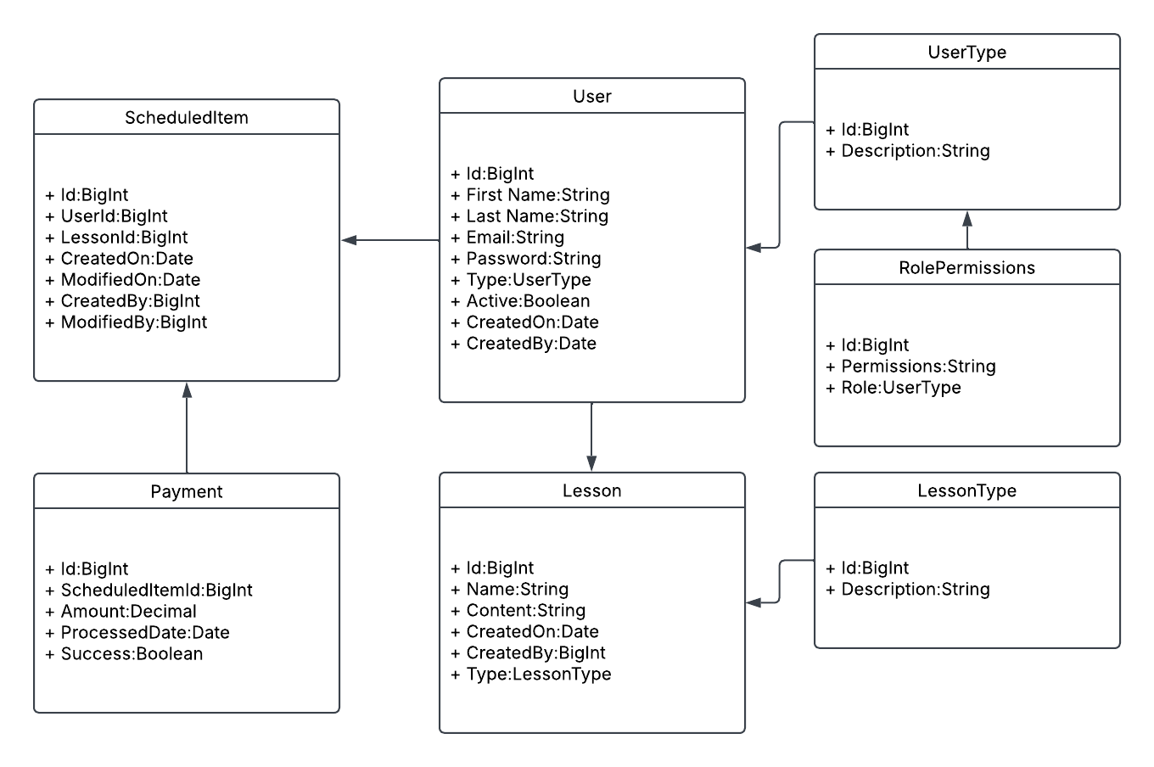

Technical Requirements

Given the above, DriverPass will need multiple technical requirements to realize their preferred system implementation. This will require computers at main location for processing students and staff needs, a cloud hosting service like Azure/AWS/Google Cloud to host the web application users will interact with, and 3rd party resources for payment processing on site and web integration for the cloud hosted application to communicate with. The software built for DriverPass will handle the content for online lessons, scheduling lessons, managing users, etc. with mentioned integrations for a holistic solution centralized for DriverPass to use efficiently.

